WELCOME
ISREV XXIV in Riga, Latvia

This is a welcoming letter to our next ISREV seminar that will take place in Riga, Latvia from Sunday, July 27 to Friday, August 1, 2025. The letter also contains information of the submission of the paper proposals. The local organizers represent three different universities in Latvia (Latvia University, Riga Technical University and Daugavpils University), but the event will be organized in Riga, in the premises of Latvia University. The seminar will be organized in hybrid format allowing also online participation.

ISREV seminars each have a theme, but all papers need not be related to the theme. If there is a publication connected to the seminar (in the past, there have been books and journal special issues), then it will only be papers on the main theme that will qualify for that publication. But all religious education topics can be submitted for the event. The theme of the seminar in Riga is:

Religious education in turbulent times: How to foster hope and well-being of young people?

How can religious and values education sustain hope in the time of political, cultural, and ecological distress? How can RE education foster well-being and resilience in the world of uncertainties and constant crises? In the face of multiple challenges, how can RE contribute to enhancing dialogue and human flourishing? There is a need for new research that would shed light on the role of RE in preparing young people to face the challenges of our time both on the individual and collective level. The interconnectedness of technology, religion and education is a theme that deserves more scholarly interest in the field of RE and where RE faces similar challenges to humanities at large. A critical role of RE is to prepare young people to navigate the complex and technologized world, to find meaning and feel at home, as well as foster autonomy and critical awareness.

Our Plenary Speakers:
Prof. Mary Hess (USA)
Prof. Gerdien Bertram-Troost (Netherlands)
Associate prof. Ole Andreas Kvamme (Norway)
Dr. Kevin O’Grady: (UK)
Prof. Manfred Pirner (Germany)

Conference Venue
The conference will be held in the new Latvia University buildings: House of Nature (completed in 2015) and House of Science (completed in 2019), (Jelgavas iela 1, Torņkalns, Riga), which has become an academic centres of Latvia University (see the images latvia university house of nature and house of science - Search Images (bing.com)) . The buildings are located in 10 min walking distance from Latvian National Library (see: Latvia National library in pictures - Search (bing.com) )

Rooms
In these buildings there are plenty rooms available (with sufficient capacity) for our presentations, workshops, coffee and recreation.

Accommodation
The only hotel which agreed to ‘cement’ the accommodation prices for Summer, 2025 (in order to keep the conference costs as low as possible) is Bellevue Park Hotel (****), which is located 1.7 km from the conference venue (walk – 20 min, public transport 15-20 min). See: BELLEVUE PARK HOTEL RIGA (hotel-ds.com)
E70 per night, breakfast included. Free parking available.
There are different other hotels in the area, but the prices will be higher.

Transport
Riga airport is about 8 km from Bellevue Park Hotel, and takes about 20 min by car depending on traffic. Public transport is available (Bus 22, approx. 30 min.). There are different Taxi services, also Bolt service is available.
The Main Railway Station “Riga” and Central Bus Station “Riga” is about 4 km from Bellevue Park Hotel, also public transport available.

Catering
We will meet all special dietary needs. The dietary requests can be listed when registering to the seminar.

Possible outings (to be confirmed later):
- Old city of Riga and its many attractions
- Jewish tour – Žanis Lipke Memorial, Riga Ghetto and Latvian Holocaust Museum
- Atheistic and traumatic past –Museum of the Occupation of Latvia, The Corner house (former headquarters of KGB), Riga Nativity of Christ Orthodox Cathedral (former Planetarium)
- Art as a powerful ideological tool – Art Nouveau, Latvian National Museum of Art
- Science as Religion – Latvian Academy of Sciences roof, The University of Latvia Academic centre, National Library of Latvia
Many other options – we will come up with more detailed proposal when time gets closer

Total Costs
A total cost of the on-site seminar is 650 euros per person.
For the online participants the fee is 50 euros per person.

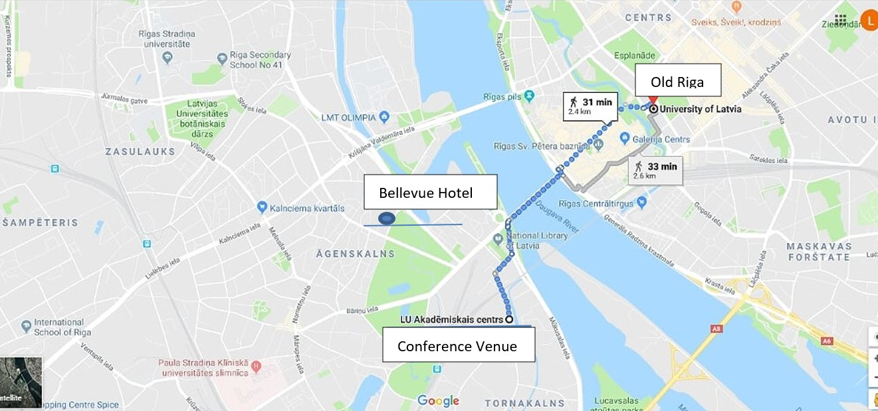

Abstract submission
Please submit your collegial paper proposal or symposium proposal using the forms attached to this email and use this link for submission:
https://link.webropolsurveys.com/S/1AE0FBF50741F677
The deadline for the abstract is Mon 16th September 2024. The results of the review of the abstracts will be communicated to the authors by 18th November 2024.

Best wishes,

The local organizers:

Laima Geikina (Latvia University, Riga, Faculty of Theology)
Lasma Latsone (Riga Technical University, Liepaja Academy, Center of Education and Social Work)
Dzintra Ilisko (Daugavpils University, Institute of Humanities and Social Sciences)
The chair of the scientific programme committee:
Saila Poulter

